**Architecture Document**

(The student team can select one of the following architectures for their project and they should provide a detailed explanation: Microservices, Event-Driven Architecture, Serverless, or Monolithic architectures. Additionally, they **should create relevant diagrams,** such as use case, class, DFD, component, sequence, and deployment diagrams, to support their project.)

**1. Application**

**1.1 Microservices**

The application follows a microservices-based architecture. Each disease prediction module (heart, kidney, diabetes, etc.) operates as an independent service with its own model logic, dataset, and preprocessing pipeline. Similarly, the medical chatbot (powered by LLaMA3) is treated as a separate microservice. This modular approach allows independent development, testing, and deployment of each component without affecting others.

**1.2 Event-Driven**

The system is partially event-driven. User interactions in the UI (e.g., selecting a disease, submitting patient data, or asking a question to the chatbot) trigger specific events that invoke the corresponding service or model. These events are asynchronous and are handled dynamically by the respective services without continuous polling.

**1.3 Serverless**

The application exhibits serverless behavior as most operations (model predictions, chatbot responses) are executed on-demand in response to user actions. There is no long-running backend service; instead, models are loaded and executed only when required. This ensures efficient resource utilization and scalability.

**2.Architecture Diagram:**

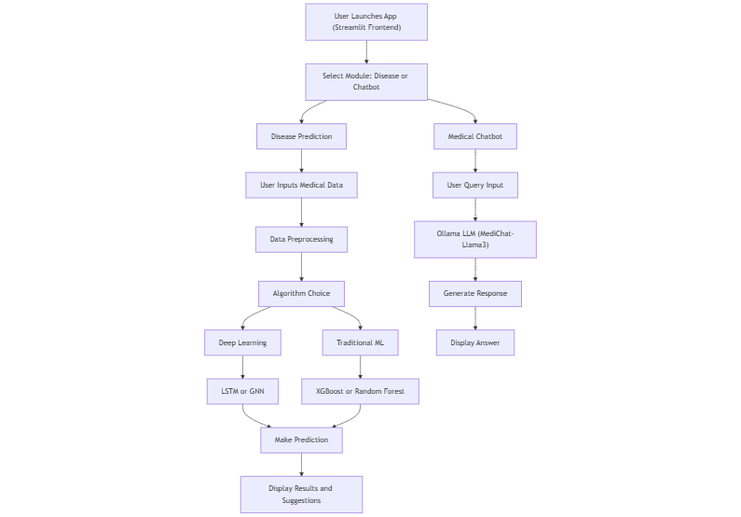

**3 Data Exchange Contract**

**2.3.1 Frequency of Data Exchanges**

* Data exchanges are **on-demand** and occur only when a user submits input for disease prediction or chatbot interaction.
* No real-time streaming or periodic data sync is involved.

**2.3.2 Data Sets**

* diabetic_data.csv
* kidney_disease.csv
* heart.csv
* liver.csv
* sepsis.csv.xlsx
* parkinsons.csv
* thyroidDF.csv
* Chatbot datasets: CancerQA.csv, Heart_Lung_and_BloodQA.csv

**2.3.3 Mode of Exchanges (API, File, Queue, etc.)**

* **File-Based**: CSV/XLSX files used for data input and storage.
* **Function Calls / Script Triggers**: Used instead of external APIs for invoking disease prediction logic.
* **Local API Simulation**: Chatbot interacts with LLaMA3 running locally, emulating a local server call.
* **No Queues** are currently implemented.